Software Design Document
Daily Deals and Discounts
A Web-Based Platform for Local Deals and Discounts



Submitted by
MUHAMMAD FAHAD
F22BINFT1M01074
Submitted to
Dr. Musarat Karim

Department of Information Technology
Faculty of Computing
The Islamia University of Bahawalpur

Summary
This Software Design Document (SDD) presents the complete design of the web-based system named Daily Deals and Discounts. The purpose of this website is to provide users with a centralized online platform where they can explore, search, and avail daily deals and discounts offered by local vendors. The system also allows vendors to promote their deals and administrators to manage platform activities.
This document describes the overall architecture, system modules, controller functions, APIs, database schema, ERD and user interface structure. The SDD outlines how customer, vendor, and admin functionalities work, how data flows through the MVC architecture, and how different modules interact with each other to ensure an efficient and user-friendly system.

Table of Contents
1. Application Architecture 4
2. Data Model Schema 7
3. User Interface 9

- Application Architecture
The Daily Deals and Discounts website follows the Model–View–Controller (MVC) architectural pattern. This architecture separates the application into three main components, improving modularity, ease of maintenance, and future extensibility.
Architecture Components
Models
Models represent the data and business logic of the system. The proposed models include:
- User
- Vendor
- Admin
- Deal
- Category
- Order
- Review

Controllers
Controllers handle user requests, process data through models, and return responses via views.
- UserController
  - User registration and login
  - Profile management
  - Browsing and searching deals
  - Placing orders and submitting reviews
- VendorController
  - Vendor registration and authentication
  - Creating, updating, and deleting deals
  - Managing deal status and availability
- AdminController
  - Approving users and vendors
  - Managing categories and deals
  - Monitoring platform activity
- DealController
  - Displaying deal listings
  - Filtering and searching deals
  - Showing deal details

Views
Views are responsible for displaying web pages to users. Major views include:
- Home page
- Login and signup pages
- Deal listing page
- Deal details page
- Vendor dashboard
- Admin dashboard

APIs and Libraries
The system uses RESTful APIs to communicate between frontend and backend components. External libraries and frameworks such as:
- Bootstrap for responsive design
- JavaScript for dynamic content and validation
- Font libraries for UI enhancement
are used to enhance usability and performance.

External APIs Used
- Google Maps Location API (or OpenStreetMap API):
Used to fetch user location, vendor store coordinates and list nearby deals.
- Geocoding API:
Converts vendor addresses into latitude/longitude.

Security Design
Security is an important aspect of the Daily Deals and Discounts system. User and vendor authentication is implemented using secure login mechanisms. Input validation is applied to prevent invalid or malicious data entry. Sensitive information such as passwords is stored in encrypted form. Role-based access control ensures that only authorized users can access vendor and admin dashboards.

Class Diagram:
The Class Diagram represents the static structure of the Daily Deals and Discounts system by showing classes, their attributes, methods, and relationships. It provides a clear overview of the system’s object-oriented design and helps in understanding how different components interact with each other.
The User class includes attributes such as userID, name, email, and password, along with methods for login, registration, and profile management. The Vendor class manages vendor-related information and includes methods for deal management. The Deal class contains attributes such as dealID, title, description, discount, and validity, along with methods to create, update, and display deals. The Category class organizes deals into specific groups. Review class manages user feedback.
Associations between classes represent real-world relationships, such as a vendor owning multiple deals and users placing multiple orders. This diagram supports modular design and improves code maintainability.

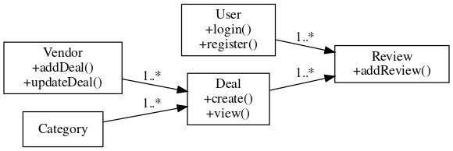
Figure 1: Class Diagram

- Data Model Schema
The database of Daily Deals and Discounts is designed using a relational database approach. Each entity represents a real-world object and maintains relationships with other entities to ensure data consistency and integrity.
Entities Description
- User
  - Stores user information such as name, email, password, and account status.
- Vendor
  - Stores vendor business details including shop name, contact information, and authentication data.
- Deal
  - Contains deal title, description, discount percentage, validity period, and vendor reference.
- Category
  - Represents different deal categories such as food, electronics, fashion, and services.
- Review
  - Stores user ratings and feedback for deals.
Entity Relationships
- One vendor can create multiple deals
- Each deal belongs to one category
- Users can submit reviews for deals

ER Diagram:
The Entity Relationship (ER) Diagram represents the conceptual database structure of the Daily Deals and Discounts website. It illustrates the major entities involved in the system and the relationships among them. The ER diagram is designed to ensure data consistency, reduce redundancy, and support efficient data retrieval.
The User entity stores information related to registered users such as name, email, and login credentials. The Vendor entity represents businesses that publish deals on the platform. The Deal entity contains deal-related information including discount details, validity period, and vendor reference. The Category entity classifies deals into different types such as food, electronics, and fashion. Review entity stores user feedback and ratings for deals.
The relationships show that one vendor can create multiple deals, one user can place multiple orders, and each deal belongs to a single category. Users are also allowed to submit reviews for deals. This ER design ensures smooth data flow and logical representation of real-world interactions.

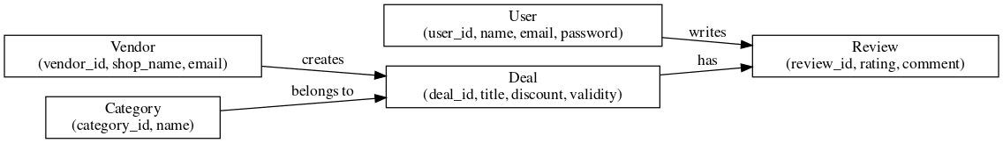
Figure 2: ER Diagram

- User Interface
The user interface of the Daily Deals and Discounts website follows a clean, modern, and user-friendly design philosophy. The color scheme uses light backgrounds with highlighted discount colors to attract user attention. The website is fully responsive and optimized for desktop, tablet, and mobile screens.

Main Screens / Pages
- Home Page
  - Displays featured, trending, and latest deals
- User Login / Signup Page
  - Allows users to register and log in securely
- Deal Listing Page
  - Shows all available deals with search and filter options
- Deal Detail Page
  - Displays complete deal information and vendor details
- Vendor Dashboard
  - Allows vendors to add, update, and manage deals
- Admin Dashboard
  - Enables administrators to manage users, vendors, and deals

UI Controls and Inputs
- Textboxes for login, signup, and search
- Dropdowns for category and location selection
- Buttons for actions such as login, signup, add deal, update deal, and purchase
- Input validation is applied to ensure correct and secure data entry

UI Mockup / Wireframe:
The UI Mockup / Wireframe diagram represents the main screens and navigation structure of the Daily Deals and Discounts website. It shows how users browse deals, view deal details, and access vendor and admin dashboards. The diagram focuses on deal viewing and management features, as the order or purchase functionality is not included in the system.

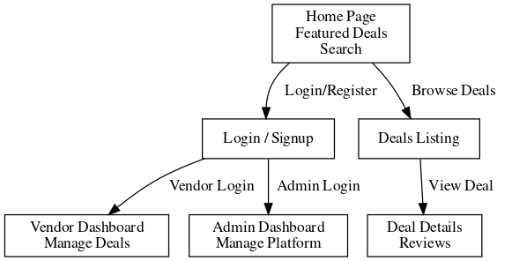
Figure 3: UI Mockup / Wireframe

